ENVIRONMENTAL ASSOCIATES

OF

LOUISIANA

Sewper Rx – Sludge Digester

U.S. PATENT NUMBER: 6884351

Product Description
Sewper Rx is a polymicrobial blend of ecologically engineered bacteria, enzymes, and nutrients, scientifically formulated for the biodegradation of organic compounds found in all types of wastewater systems. Sewper Rx bacteria have been subjected to a process known as anhydrobiotic engineering which causes them to change their behavior, allowing them to adapt to any environment.

Among the many species found in this mixture are several gram negative rods, known for their ability to degrade many environmental pollutants but also known for their fragility. They are usually delivered in liquid form and must be regularly metered into the waste stream. Our patented manufacturing process gives them the ability to survive drying, allowing for a much longer shelf life, much hardier bacteria and much easier and less costly application. They are both motile (swimmers) and sessile (able to form biofilms), produce extremely high levels of enzymes necessary for the rapid digestion of fats, oils, grease, carbohydrates, proteins and cellulose and double their CFU count every 24 minutes.

Sewper Rx completely eliminates, or greatly reduces odors, dramatically reduces solids/sludge, reduces foaming, and promotes settling and clarifying, resulting in reduced BOD and TSS in final effluent. Sewper Rx also achieves nitrification and denitrification and phosphorus removal without the need for separate processes. Significant savings are achieved in solids handling, separation, storage, hauling and disposal and other costs related to the solids elimination process, while consistently meeting ever-tightening discharge standards. In many cases, significant electrical savings are also realized.

Applications
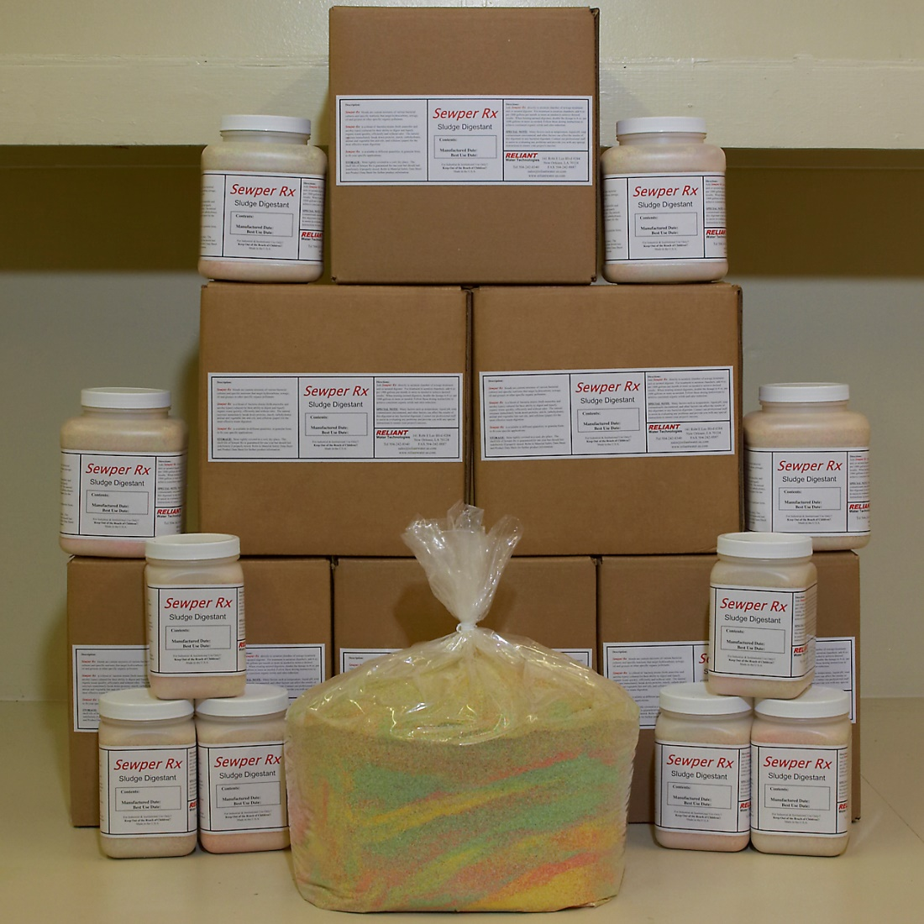
Activated Sludge Wastewater Systems
Facultative Lagoons and Holding Tanks
Lift Stations and Collection Systems
Digesters and Grease Traps
Poultry Litter and Hog Waste Lagoons

Physical Properties
Form: Multicolored or tan powder
Shelf Life: 1 year guaranteed
Pathogen free

Dosage
Varies, depending upon waste/concentration
loading. Consult Representative for system
Manufactured by:

Environmental Associates of Louisiana
215 Guidry Road
Lafayette, LA 70503
337 412 0503-Matt Roth
matt@sewperrx.com
www.sewperrx.com

guidr
survey and dosing schedule.

Typical Application Environment
Dissolved Oxygen, mg/l 0.05-2.0 ppm
pH 4.5-10
Temperature °C 5°-55°
Temperature °F 40°-110°

